Mixtures - Introduction
DEFINITION
A mixture is two or more pure substances which are combined, but NOT chemically bonded together.

So, a mixture is NOT a pure substance (like elements and compounds). This means a mixture does not have a definite composition like elements or compounds
For Example – Oxygen gas (O₂) is always made up of 100% Oxygen atoms, and water (H₂O) is always made up of 2 Hydrogen atoms and one Oxygen atom. Elements and compounds have definite proportions, mixtures do not.

This means that the properties of a mixture will vary depending on the percent composition of the things in it.
For Example
Consider cordial drink – a mixture of sugar/flavouring/colouring dissolved in water.
If you make a cordial drink with 80% cordial and only 20% water, imagine what that will taste like... compared to:
If you make a cordial drink with 10% cordial and only 90% water, which is likely to taste much nicer.
The properties of the cordial (THE MIXTURE) have changed when the percent composition of the mixture has changed.

MIXTURES

The type of mixture is all about the particles
being mixed!
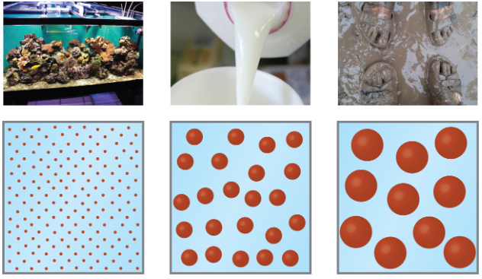
Mixture types - Solutions, Suspensions, and Colloids

The size of the particles has a great effect on the properties of a mixture. Mixtures get classified as solutions, suspensions, or colloids based on the size of the particles in the mixture.
- Solutions have tiny (invisible – molecule size) particles in them
- Colloids have very small (microscopic) particles in them
- Suspensions have small to large (macroscopic – you can see them) particles in them.
HOW to IDENTIFY a mixture
Mixtures
Translucent or opaque
Transparent
Homogeneous Heterogeneous
Does not settle out. Particles not visible
Will settle out. Can be filtered out
Solution Colloid Suspension

Solutions

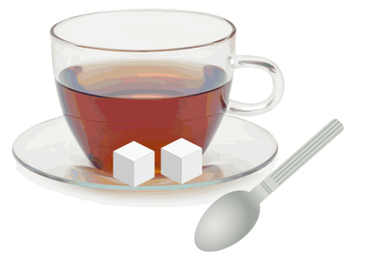
When substances dissolve and form a homogeneous mixture, the mixture is called a solution. Whatever substance there is more of is called the solvent.
The other is called the solute.
For example - In Iced tea-the water is the solvent, the tea mix is the solute).

Properties of a Solution
- Transparent - Light passes through them.
- They do not separate into layers over time.
- If they are poured through a filter, everything passes through, none of the particles will get trapped.
All of the particles in a solution are too small to scatter light, become separated, or filter out.

Suspensions
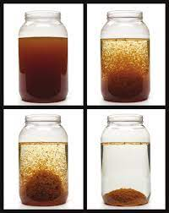
- Suspensions are mixtures in which you can see the particles in the mixture. Thus suspensions are visibly heterogeneous mixtures
- For example - Muddy water taken from a swamp is a good example.

Properties of a Suspension
- There are visible particles.
- The suspended particles settle out over time.
- Filters can separate particles that make up a suspension.
- Scatter light. (This is known as the Tyndell Effect)
The particles in a suspension are big enough to see, and will settle out into layers, can be filtered out, and scatter or block light.

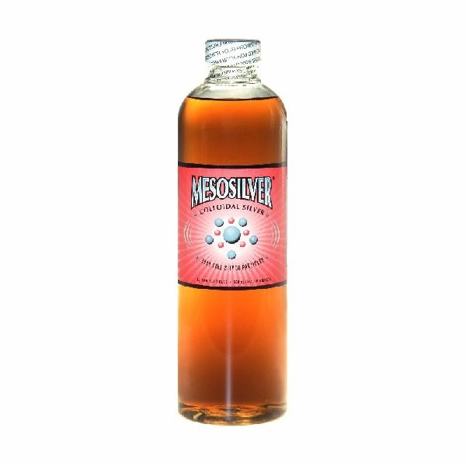
Colloids
Colloids are not transparent (can be translucent or opaque) but you cannot see the particles in them. They have very small particles in them that will not settle out or be filtered out.

Examples include Milk (tiny fat droplets in water), smooth peanut butter, vegemite, honey, pudding, whipped cream, and even fog!

Properties of Colloids
- The particles are not visible (so colloids look homogeneous, but they are classed as heterogeneous)
- Colloids do not separate into layers.
- Particles cannot be filtered out.
- Scatter light.
Colloids appear to be homogeneous (like solutions), but are not (colloids are translucent or opaque). Colloids have particles that are very small, will not separate out, be filtered out, but will scatter light.
Colloids are classified by the phases (solid, liquid, gas) of the particles in the mixture.
Particles mixed in | What it is mixed into | Name of Colloid type | Examples
Gas | Liquid | Foam | Whipped cream, soap Lather
Gas | Solid | Solid foam | Pumice stone, rubber
Liquid | Gas | Aerosol | Cloud, mist, fog
Liquid | Liquid | Emulsion | Milk, cream, mayonnaise
Liquid | Solid | Gel | Jelly, butter, curd, cheese
Solid | Gas | Aerosol | Smoke, haze
Solid | Solid | Solid-sol | Coloured glasses, gems, ruby glass

Solution | Colloids | Suspensions
Homogeneous | Heterogeneous | Heterogeneous
Particle size: 0.01nm - 1nm; (atoms, ions or molecules) | Particle size: 11-1000nm, (very large molecules or aggregates) | Particle size: over 1000nm, (large particles or aggregates)
Do not separate on standing | Do not separate on standing | Particles settle out
Cannot be separated by filtration | Cannot be separated by filtration | Can be separated by filtration
Do not scatter light | Scatter light or be opaque) | May either scatter light or be opaque

